**Boundary Layer Characterization over an Airfoil**

Charles Keer

AE 315

*Department of Aerospace Engineering*

*Embry-Riddle Aeronautical University, Daytona Beach, FL, 32114-3900*

**Introduction**

A boundary layer forms over any surface when a fluid in motion passes over it, or when the body moves through a fluid. This boundary layer forms a velocity gradient from the surface of the body to the free stream. Due to the no-slip condition, the particles at the surface of the body will have close to zero velocity with respect to the body. The velocity will increase exponentially with respect to height until it reaches the free-stream velocity.

**Figure 1.** Schematic of experiment setup.

|  |  |
| --- | --- |
| **Test Parameter** | **Test Condition** |
| Ambient Pressure (Pascals) | 101400 |
| Ambient Temperature (Kelvin) | 299.8 |
| Reynolds Number Flat Plate 10m/s | 290900 |
| Reynolds Number Flat Plate 15m/s | 436350 |
| Dynamic Pressure 10m/s (inches of water) | 0.2366 |
| Dynamic Pressure 15m/s (inches of water) | 0.5322 |

During the experiment, the Kiel probe was calibrated by a piece of paper placed on the surface of the tunnel, directly under the probe. The probe was then lowered until it barely touched the paper. This ensured the probe was as close as possible to the surface and able to capture as much of the boundary layer as possible. Two trials were conducted for each location with the probe, one at 10m/s and one at 15m/s. During each trial, the probe was moved in very small increments vertically, approximately 1mm, until it reached a height of 25mm for the flat plate and leading edge, and 35mm for the trailing edge. Dynamic pressure was sampled at each increment.

**Table 1.** Experiment Parameters

**Results and Discussion**

To accurately compare the boundary layers at each of the pressure gradients, both the velocity and the height were normalized across all cases. For the velocity, this was achieved by sampling several points along the asymptote near the free stream velocity. These data points were averaged, and the velocity was divided by this value to normalize it. To normalize the height, a second-order polynomial fit was applied to the asymptote portion of each normalized velocity curve. The point where the velocity was 99% of the free stream velocity was the value each height was divided by to normalize it. This value also corresponds to the boundary layer height.

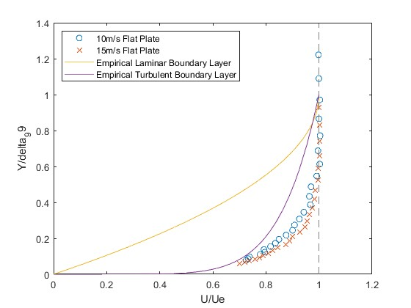In the case of the flat plate, or zero pressure gradient, the boundary layer appears to be turbulent. This can be seen in Figure 1, where the mathematical approximations of laminar and turbulent are plotted with the experimental data. The equation for a laminar approximation of the boundary layer is given by:

**Figure 2.** Zero pressure gradient boundary layer with mathematical approximations

$\frac{u}{U_{e}}=2\left(\frac{y}{δ_{99}}\right)-{(\frac{y}{δ_{99}})}^{2}$ (1)

Similarly, the equation for the approximation of a turbulent boundary layer is given by:

$\frac{u}{U_{e}}={\frac{y}{δ_{99}}}^{(\frac{1}{7})}$ (2)

|  |  |  |  |  |
| --- | --- | --- | --- | --- |
| **Pressure Gradient** | **10m/s Ue** | **15m/s Ue** | **10m/s Boundary Thickness** | **15m/s Boundary Thickness** |
| Zero | 10.04 m/s | 15.06 m/s | 32.7 mm | 43.0 mm |
| Favorable | 9.77 m/s | 15.18 m/s | 27.8 mm | 32.1 mm |
| Adverse | 10.01 m/s | 14.97 m/s | 31.0 mm | 23.8 mm |

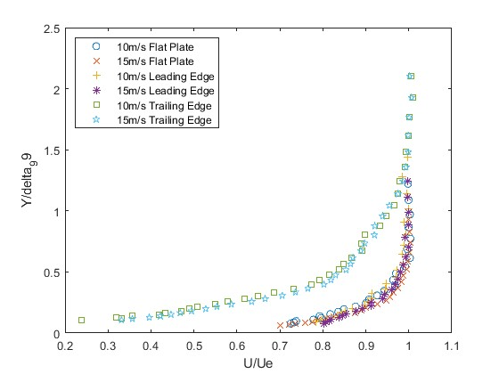According to the Reynolds number calculations done at the flat plate (zero pressure gradient), the 10m/s experiment yielded a transitional boundary layer since the Reynolds number was close to 300000 and exhibited both laminar and turbulent properties. This can also be verified through the

**Figure 3.** All normalized boundary layer profiles

**Table 2.** Boundary Layer Characteristics

information in Figure 2. Given this information, the 10m/s boundary layer can be classified as a transitional boundary layer since it has a low Reynolds number and turbulent characteristics. The 15m/s experiment produced a much higher Reynolds number of 436350, which can be classified as a turbulent boundary layer.

The boundary layer height for each case was calculated at the 99% free stream velocity. At 10m/s, the boundary layer height was approximately 32.7mm while at 15m/s, the height was 43.0mm. As the 10m/s case has a lower Reynolds number, it follows that the boundary layer should be larger. The reason for the smaller boundary layer could be due to the transition region, where it is partially turbulent and laminar.

As shown in Figure 3, the trailing edge boundary layer appears to be much more laminar than the flat plate or the leading edge. This could be from the flow reattaching on the trailing edge, transitioning from a turbulent to a laminar boundary. However, by finding the boundary layer thickness through the polynomial best-fit method, the zero pressure gradient thickness is considerably thicker than the favorable or adverse pressure gradients. This gives further evidence that the zero pressure gradient is a turbulent boundary layer. With the zero pressure gradient, it will most likely be laminar at lower Reynolds numbers. However, an adverse pressure gradient will more likely be turbulent. For this experiment, the trailing edge of the airfoil is considered an adverse pressure gradient due to the flow separation and reversed flow. This region will have the highest skin friction and therefore the highest pressure drag from the flow. Conversely, the most efficient way to have the flow reattach would be to have the transition layer be as far as possible from the leading edge and a strong adverse pressure gradient. This would cause the highest drag but also keep the flow from separating for as long as possible.

|  |  |  |  |
| --- | --- | --- | --- |
| Velocity | Zero Gradient | Empirical Laminar | Empirical Turbulent |
| 10 m/s | 0.0013159 | 0.0012311 | 0.0046362 |
| 15 m/s | 0.0021570 | 0.0010052 | 0.0042751 |

**Table 3.** Skin friction coefficients for different pressure gradients

As shown in Table 3, the skin coefficients for the flat plate are roughly between the empirical laminar and empirical turbulent coefficients, giving further evidence that the boundary layer at the zero pressure gradient is transitional, due to its location downstream from the flow.

**Conclusions**

Boundary layers are critical in understanding how drag and pressure affects the flow over obstructions. In this experiment, the boundary layer at a zero pressure gradient, favorable pressure gradient, and adverse pressure gradient was studied. It was proven that the boundary layer characteristics differed across the pressure gradients, leading to differing skin friction coefficients. It was additionally proven that the increase in Reynolds number led to a more turbulent boundary layer while a lower Reynolds number was more indicative of a laminar boundary layer.

**References**

Department of Aerospace Engineering. *AE 315 Experimental Aerodynamics Lab 4.* Canvas

**MATLAB Code**

clc;

clear;

close all

R=287;

%load the data into the workspace

%Define Flat Plate Directory

dirName_FP=fullfile('D:\Github\School\Aero Lab\Lab 4\Data\Lab 4\Flat Plate')

fName_10_FP='fp_10mps_';

fName_15_FP='fp_15mps_';

%Define Leading Edge Directory

dirName_LE=fullfile('D:\Github\School\Aero Lab\Lab 4\Data\Lab 4\Leading Edge')

fName_10_LE='le_10mps_le';

fName_15_LE='le_15mps_le';

%Define Trailing Edge Directory

dirName_TE=fullfile('D:\Github\School\Aero Lab\Lab 4\Data\Lab 4\Trailing Edge')

fName_10_TE='te_10mps_te';

fName_15_TE='te_15mps_te';

%Load Flat Plate 10m/s data

for i=1:25

data_FP_10(i)=load(fullfile(dirName_FP,[fName_10_FP '_' num2str(i) '.mat']));

FP_10_density(i)=data_FP_10(i).pAtm.*3386.38867/(R.*data_FP_10(i).tAtm); %kg/m^3

FP_10_velocity(i)=sqrt(2*mean(data_FP_10(i).dp*249.0889)/FP_10_density(i));

FP_10_zcurr(i)=data_FP_10(i).zCurr*0.0254;

end

%Load Flat Plate 15m/s data

for i=1:25

data_FP_15(i)=load(fullfile(dirName_FP,[fName_15_FP '_' num2str(i) '.mat']));

FP_15_density(i)=data_FP_15(i).pAtm.*3386.38867/(R.*data_FP_15(i).tAtm); %kg/m^3

FP_15_velocity(i)=sqrt(2*mean(data_FP_15(i).dp*249.0889)/FP_15_density(i));

FP_15_zcurr(i)=data_FP_15(i).zCurr*0.0254;

end

%Load Leading Edge 10m/s data

for i=1:25

data_LE_10(i)=load(fullfile(dirName_LE,[fName_10_LE '_' num2str(i) '.mat']));

LE_10_density(i)=data_LE_10(i).pAtm.*3386.38867/(R.*data_LE_10(i).tAtm); %kg/m^3

LE_10_velocity(i)=sqrt(2*mean(data_LE_10(i).dp*249.0889)/LE_10_density(i));

LE_10_zcurr(i)=data_LE_10(i).zCurr*0.0254;

end

%Load Leading Edge 15m/s data

for i=1:25

data_LE_15(i)=load(fullfile(dirName_LE,[fName_15_LE '_' num2str(i) '.mat']));

LE_15_density(i)=data_LE_15(i).pAtm.*3386.38867/(R.*data_LE_15(i).tAtm); %kg/m^3

LE_15_velocity(i)=sqrt(2*mean(data_LE_15(i).dp*249.0889)/LE_15_density(i));

LE_15_zcurr(i)=data_LE_15(i).zCurr*0.0254;

end

%Load Trailing Edge 10m/s data

for i=1:35

data_TE_10(i)=load(fullfile(dirName_TE,[fName_10_TE '_' num2str(i) '.mat']));

TE_10_density(i)=data_TE_10(i).pAtm.*3386.38867/(R.*data_TE_10(i).tAtm); %kg/m^3

TE_10_velocity(i)=sqrt(2*mean(data_TE_10(i).dp*249.0889)/TE_10_density(i));

TE_10_zcurr(i)=data_TE_10(i).zCurr*0.0254;

end

%Load Trailing Edge 15m/s data

for i=1:35

data_TE_15(i)=load(fullfile(dirName_TE,[fName_15_TE '_' num2str(i) '.mat']));

TE_15_density(i)=data_TE_15(i).pAtm.*3386.38867/(R.*data_TE_15(i).tAtm); %kg/m^3

TE_15_velocity(i)=sqrt(2*mean(data_TE_15(i).dp*249.0889)/TE_15_density(i));

TE_15_zcurr(i)=data_TE_15(i).zCurr*0.0254;

end

%Calculate the U/Ue for each trial

FP_10_UE=FP_10_velocity/mean(FP_10_velocity(20:25));

FP_15_UE=FP_15_velocity/mean(FP_15_velocity(20:25));

LE_10_UE=LE_10_velocity/max(LE_10_velocity);

LE_15_UE=LE_15_velocity/max(LE_15_velocity);

TE_10_UE=TE_10_velocity/mean(TE_10_velocity(30:35));

TE_15_UE=TE_15_velocity/mean(TE_15_velocity(30:35));

%Do a curve fit for each case

FP_10_fit=polyfit(FP_10_UE(20:25),FP_10_zcurr(20:25),2);

FP_15_fit=polyfit(FP_15_UE(20:25),FP_15_zcurr(20:25),2);

LE_10_fit=polyfit(LE_10_UE(20:25),LE_10_zcurr(20:25),2);

LE_15_fit=polyfit(LE_15_UE(20:25),LE_15_zcurr(20:25),2);

TE_10_fit=polyfit(TE_10_UE(30:35),TE_10_zcurr(30:35),2);

TE_15_fit=polyfit(TE_15_UE(30:35),TE_15_zcurr(30:35),2);

%Find the 99 percent point

FP_10_z99=abs(polyval(FP_10_fit,0.99*mean(FP_10_UE(20:25))))

FP_15_z99=abs(polyval(FP_15_fit,0.99*mean(FP_15_UE(20:25))))

LE_10_z99=abs(polyval(LE_10_fit,0.99*max(LE_10_UE(20:25))))

LE_15_z99=abs(polyval(LE_15_fit,0.99*mean(LE_15_UE(20:25))))

TE_10_z99=abs(polyval(TE_10_fit,0.99*mean(TE_10_UE(30:35))))

TE_15_z99=abs(polyval(TE_15_fit,0.99*mean(TE_15_UE(30:35))))

%Divide by the 99 pecent point to normalize the x axis

FP_10_zfinal=FP_10_zcurr/FP_10_z99;

FP_15_zfinal=FP_15_zcurr/FP_15_z99;

LE_10_zfinal=LE_10_zcurr/LE_10_z99;

LE_15_zfinal=LE_15_zcurr/LE_15_z99;

TE_10_zfinal=TE_10_zcurr/TE_10_z99;

TE_15_zfinal=TE_15_zcurr/TE_15_z99;

laminar_boundary= @(x) 1-sqrt(-x+1);

turbulent_boundary= @(x) x^(7);

plot(FP_10_UE,FP_10_zfinal,"o",FP_15_UE,FP_15_zfinal,"x")

xlabel("U/Ue")

ylabel("Y/delta_99")

hold on

fplot(laminar_boundary,[0 1])

fplot(turbulent_boundary, [0 1])

legend("10m/s Flat Plate", "15m/s Flat Plate","Empirical Laminar Boundary Layer", "Empirical Turbulent Boundary Layer","Location","northwest")